SERPS 101/Findability Overview

Overview:
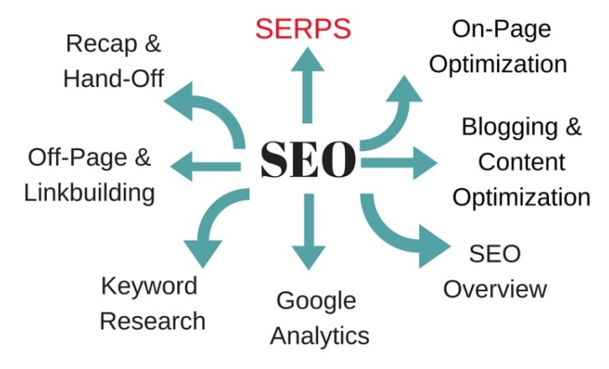
- SERPs stands for Search Engine Results Page
- Understanding and scrutinizing this page is a key foundational element for SEO
- Here are the primary things you need to understand:
  - Skip past the paid ads
  - The difference between being logged in and out, and searching incognito

Your Homework:

Assess Competitors
- Log out – OR search incognito
- Type in a handful of keywords: ideally, general keywords that represent your industry, a keyword you’ve targeted in a blog post, and a keyword that indicates someone would be looking for your products, services or solutions.
- Analyze the SERPs after typing in a keyword: It’s very important to understand keyword competitors.
  - Look at the mix of sites that are ranking: Who is currently ranking for the keywords you want?
    - Note – are they a TRUE competitor? A media site? A directory? Wikipedia? A social channel? Industry sites? An industry association?
    - Know who you can and can’t out-seat. The importance of practical keywords and longtail keywords.
  - Look at the URL of the page that the keyword is going to
    - Not always the homepage – sometimes it is an internal page
  - Start noticing title tags/meta descriptions
    - Is there a keyword being used? It the usage spammy or natural
    - Every page gets its own unique keyword, title tag, and meta description
    - What will appeal to your prospect? Language, CTA, etc.
    - Is it too lengthy and truncate?
    - Brand name?
- Assess your results:
  - Is your site coming up? (hint: do a CTRL+F to quickly sort through the results)
  - What does the title tag/meta description combo LOOK like?
  - Put yourself in your prospect’s shoes – would YOU click on your result if you were them? Or a competing result?
  - We will be strategically improving these throughout your program for your most important core pages, and also blog posts and other content.

Search Engines Outside of Google
Read this excerpt from a recent blog post:
-----------------------------------------

Case Study of How Searchers Search Today
In my research for the “Future of SEO” panel, I stumbled across this article that detailed how the author’s girlfriend came to purchase all of the furniture for their new loft in downtown Miami(forget the sensationalized and misleading heading for a moment). He documented her search process:
- First she went to Pinterest to find inspiration using keywords like “loft decorations” and then narrowed down to specific pieces of furniture.
- Next came Amazon, where she searched with keywords based on the rustic furniture she liked on Pinterest. She wasn’t overly thrilled at the results.
- Then she moved on to Ebay where she could find cheaper, secondhand furniture there. Still didn’t like what she found.
- Finally she landed on Etsy, where she purchased all furniture (subsequently breaking the author’s bank account).
What’s incredible about this, is that she completely bypassed Google. Google was an extra step she didn’t want to spend time on. Think about it: is Google now an extra step in the process for your prospects and customers?
I read this somewhere (apologies I can’t cite the source) that really struck a nerve: SEO hasn’t changed. Your customer has changed. Their buying patterns, internet surfing habits, favorite places to hang out and read, are evolving.

Now, think about how you search….
Did you know that mobile phone users spend 90% of their time within apps? I know that when I want a recipe, I go straight to Pinterest. When I’m looking for the nearest Starbucks, I go straight to my Starbucks app. My 20-minute Jillian Michaels workout? Straight to my YouTube app. How about you?

-----------------------------------------

If You Can’t Beat ‘Em…
- What other websites do you keep seeing? YouTube? Quora? LinkedIn Pulse? Amazon?
- Where else should you have a presence?
- Where else do you need to distribute your content to and optimize it – away from your site – to make your content findable?
- Google is NOT the only search engine – what other “search engines” might your prospects turn to besides Google? Do a search for your same keywords on Twitter, Amazon, and YouTube.

In Sum:
- Ranking is only half the battle. Getting people to CLICK on your result is the key!
- You have to know WHO you are competing with and how realistic/practical your chance of outseating them is. This is why we’ll go after a mix of competitive and less competitive words for your site.
- Other sites can be search engines – a big change with SEO
- Purposeful marketing is what we’re about to embark on. Every step along the way is critical.

What Ideas Do You Have?
Jot down a few takeaways and ideas and share with Jenny. Your feedback and brainstorming is an important part of this next step. What resonates and what doesn’t?

